

# VINEGAR FOOD

**Supervisor:** *NGUYỄN HẠ VY*

**Semester:** *01*

**Batch No:** *T1.2208.M2*

**Group No:** *06*

|  |  |  |
| --- | --- | --- |
| **Order:** | **Full name** | **Roll No.** |
| *1.* | *THÂN TÂM NHƯ* | Student1414246 |
| *2.* | *PHẠM NGỌC HẢI* | Student1414366 |

***Month****: 11* ***Year****: 2022*



This is to certify that

**Ms. THÂN TÂM NHƯ Mr. PHẠM NGỌC HẢI**

Have successfully Designed & Developed

# VINEGAR FOOD

Submitted by:

**Ms. NGUYEN HA VY**

Date Of Issue:

Authorized Signature:

# Content

Content Acknowledge Synopsis

Review 1

Review 2

Review 3 ..

Tasksheet ..

# Acknowledge

As we understand that the eProject is a step-by-step learning environment that closely simulates the classroom and Lab-based learning environment into actual implementation. It is a project implementation at your fingertips!! An electronic, live juncture on the machine that allows you to.

* Practice step by step i.e. laddered approach.
* Build a larger more robust application.
* Usage of certain utilities in applications designed by user.
* Single program to unified code leading to a complete application.
* Learn implementation of concepts in a phased manner.
* Enhance skills and add value.
* Work on real-life projects.
* Give a real-life scenario and help to create applications that are more complicated and useful.
* Mentoring through email support.

First of all, I would like to thank India Aptech for allowing my team to work on this fantastic eProject. We had a great experience with eProject this time.

Next, We would like to express my special thanks to our mentor, Ms. Ha Vy for the time and effort that she provided throughout the project. Your helpful advice and suggestions were beneficial to us during the completion of the project. In this respect, We are forever grateful to you.

Besides several mistakes we made in the project, we hope to have more opportunities to widen our knowledge in the web-developing world.

We will try to continue to learn and improve ourselves even more in the future.

Yours Sincerely, Team Group 06.

# Synopsis

The Objective of this program we aim is to give a sample project to work on real- life projects. These applications help us build a larger more robust application.

The objective is not to teach us HTML/JavaScript but to provide us with a real-life scenario and help us create basic applications using the tools.

Hence, we can revise the chapters before we start with the project.

This project is meant for students like us who have completed the module of HTML5. These programs should be done in the Lab sessions with the assistance of the faculty if required.

The website (in this project) is a tool that brings everything in the world to you such as historic monuments information natural knowledge and skill in technology...

It is very essential for us that will have a clear understanding of the subject. We think we should go through the project and solve the assignments as per the requirements given.

And get back [***eprojects@aptech.ac.in***](mailto:eprojects@aptech.ac.in) as the assigned schedule.

## Problem Definition

**Vinegar Food** Restaurant which is the flagship brand of JADONS Ltd has spread over

its aroma in this industry over the past few decades. Known as “the Serving plates”

with 72 different rotating menus and 240000 delicacies throughout the country.

The organization wants a website to be made which should spread the aroma online.

The main Highlights of the restaurant must be highlighted in the website. The

restaurant has more than 1000 branches till date.

The website is to be developed for the Windows Platform using HTML5, JavaScript

and Geolocation. The site should work well in all leading browsers including Chrome,

IE, Firefox etc.

Requirement Specification:

The Web site is to be created based on the following requirements.

1) Home page must add header section with an image which would show

different range of dishes images.

2) The menu list must be added in one section of the website

3) The bottom navigation panel must be designed.

4) Navigation of the website must be made user friendly.

5) Links such as

- Home

- About us

- Meals

i. Regular

ii. Lunch

iii. Snacks

iv. Desert

v. Beverages

- Gallery

- Awards

- Catering

- Recipe of the month

- Contact us

- Feedback (can add query, suggestion or complaints)

6) You can add additional links as well as modify but make sure all the type of

food must be included.

7) Look and feel must be made user friendly.

8) Uniformity and Navigation must be made smooth throughout the website.

9) Site map, Gallery, about us, Queries link must be added.

10) There should be a “Contact Us” page which will have the Address of the

Company which should be displayed using GeoLocation API (eg. GoogleMaps)

and the email address which when clicked will invoke the local mail client

from where they can send an email.

## Customer Requirements Specifications

### User:

#### input:

* Information on search.
* Feedback to the webmaster.

#### Process:

* Use Javascript to do it.
* Check the feedback of users.

#### Output:

* Result of searching.
* Confirm the feedback of the users.

### Hardware/ software requirement:

#### Software:

* + Notepad/HTML editor
  + Dreamweaver
  + IE 5.0/ Netscape 6.0

#### Hardware:

* + A minimum computer system that will help you access all the tools in the courses is a Pentium 166 or better
  + 64 Megabytes of RAM or better

|  |  |
| --- | --- |
| **Document Name**:  Architecture and design of the project | **SWD/Form** No.03/ARD/Ver1.0 |
| **Version** 1.0 | **Page 3** |

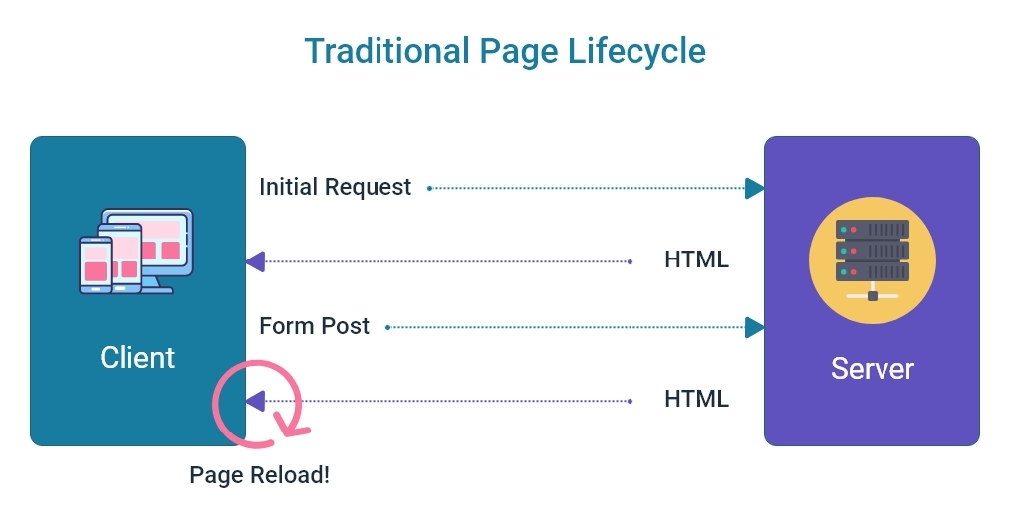



Home

Contact

Carousel

About us

Product Card

Login

Register

Product Details

Add to cart/View

# Open server

***+Windows/MacOS:***

Step 1: Open folder server with link my-shop/server.

Step 2: Right-click -> open Git bash/Open Terminal on VSCode

Step 3: Enter json-server –watch server.json(Note: you can use “cd server”, sure you are at folder server with file server.json in that)

Step 4: When server was created , open file index.html

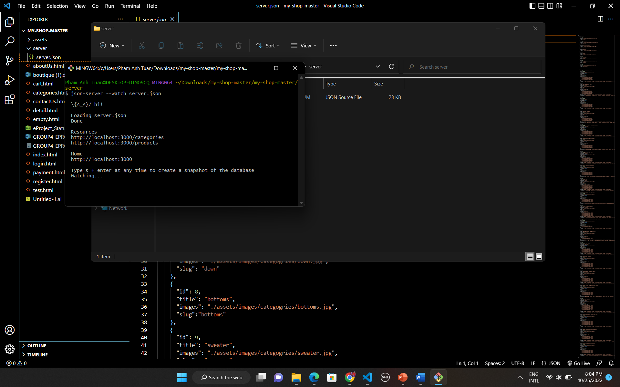

# Screenshots

# I.Homepage

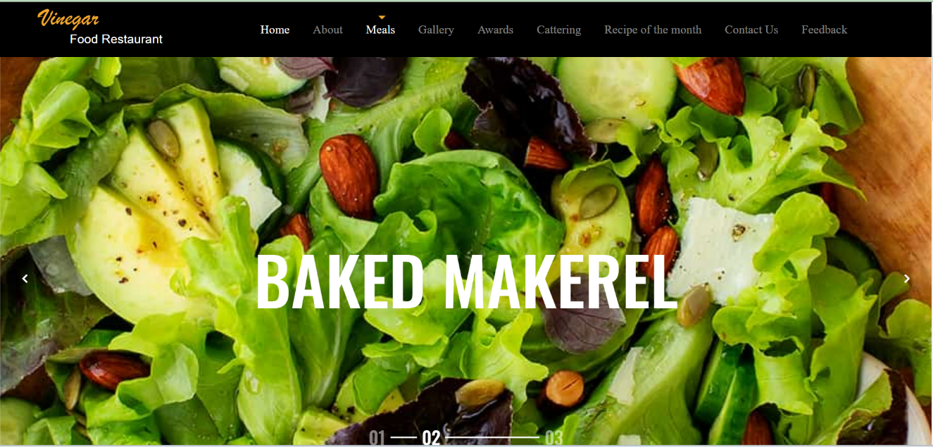

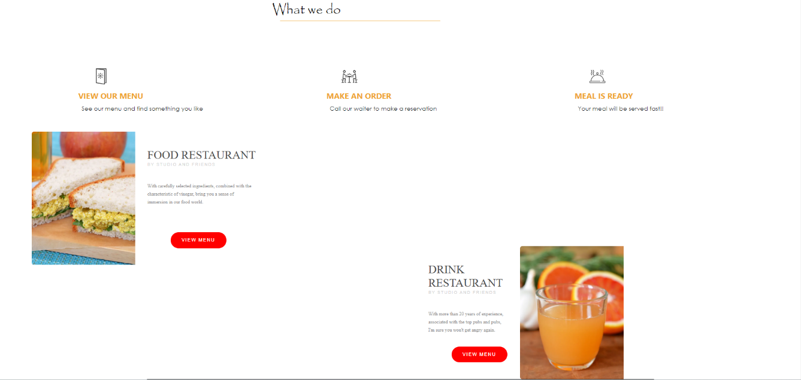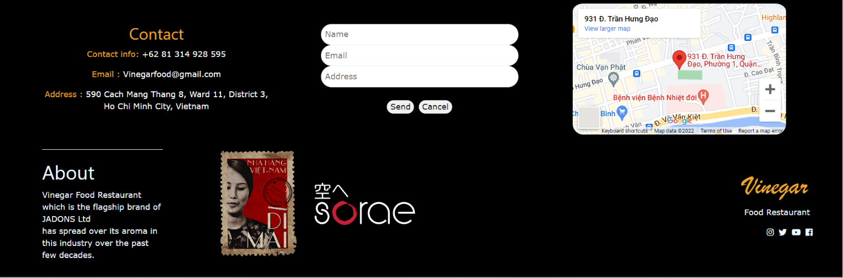

**Overview of Homepage**

**Description Homepage:**

Homepage have:

+Navbar with logo, home, about, meals, awards, catering, recipe of the month, contact us, feedback.

+Banner with carousel slide

+Categories product

+Sale product

***Screenshots about them:***



This is navbar

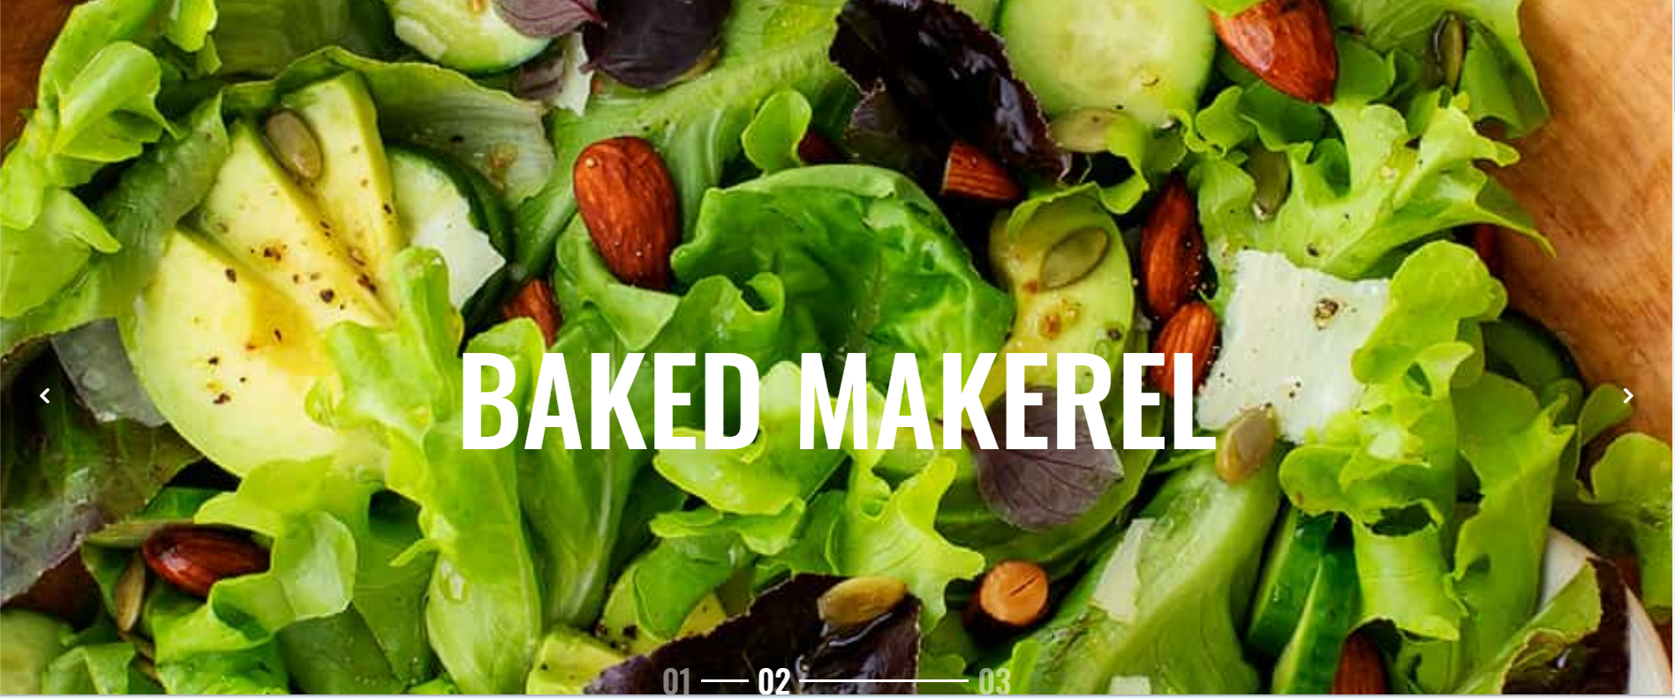

Banner

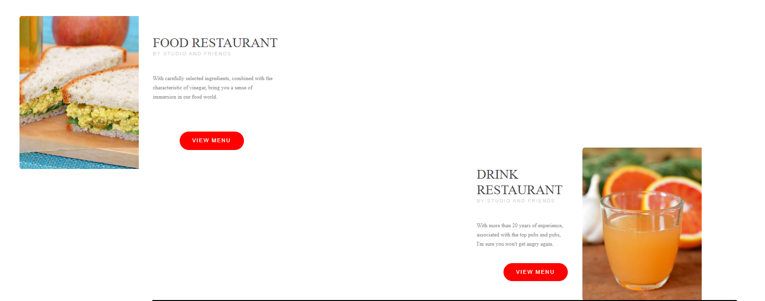

Categories product.

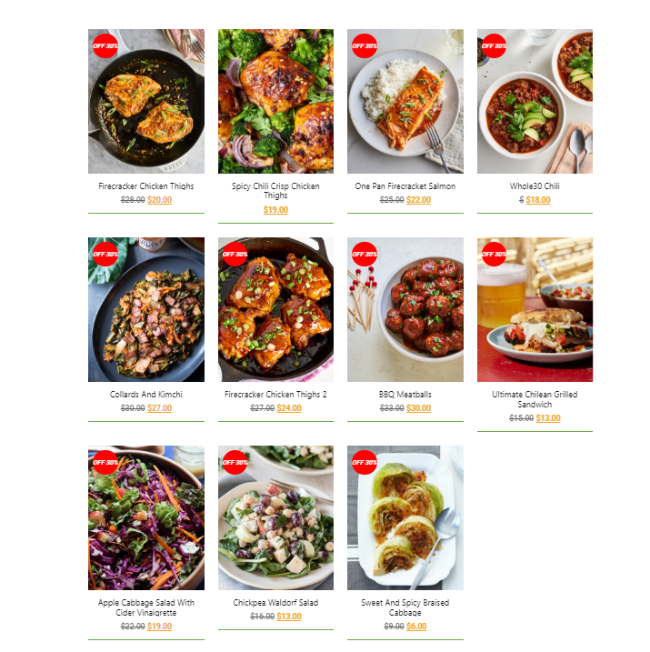

Sale product.

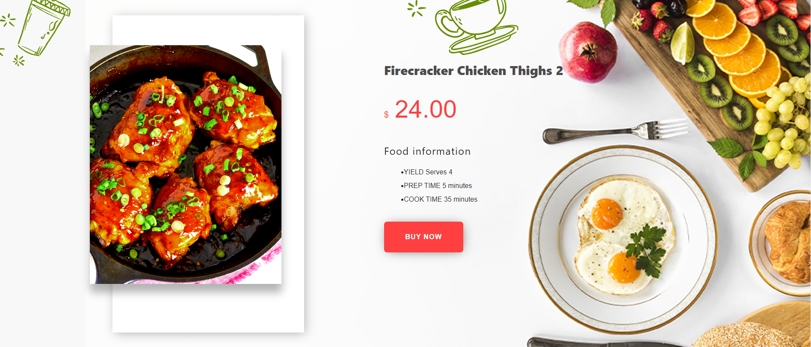

Product Detals

# II.About us:

**About us page have:**

+ Our story, our vision and a little information about stores:

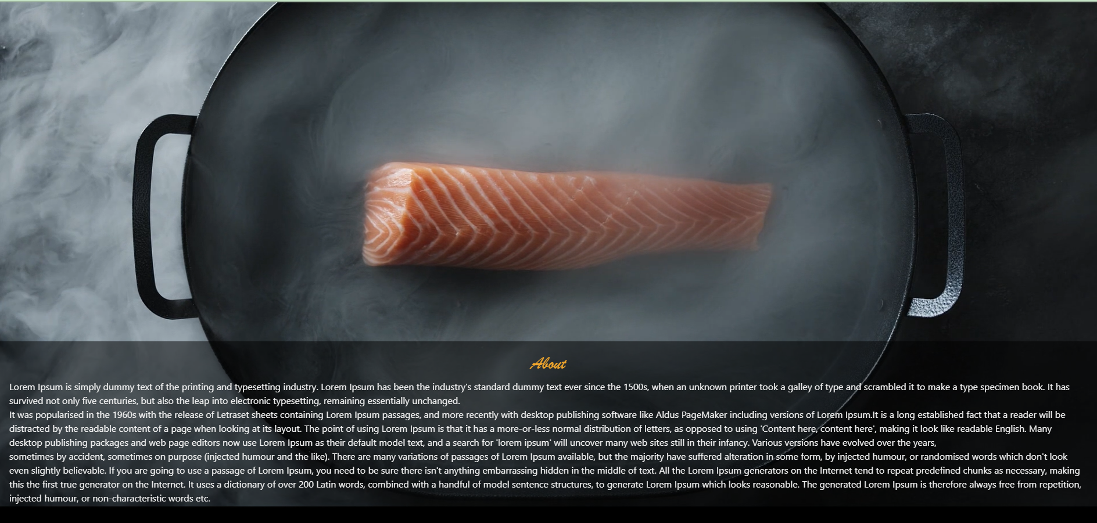

# III.Contact Us:

Contact page about:

+Form that you can use contact with store.

